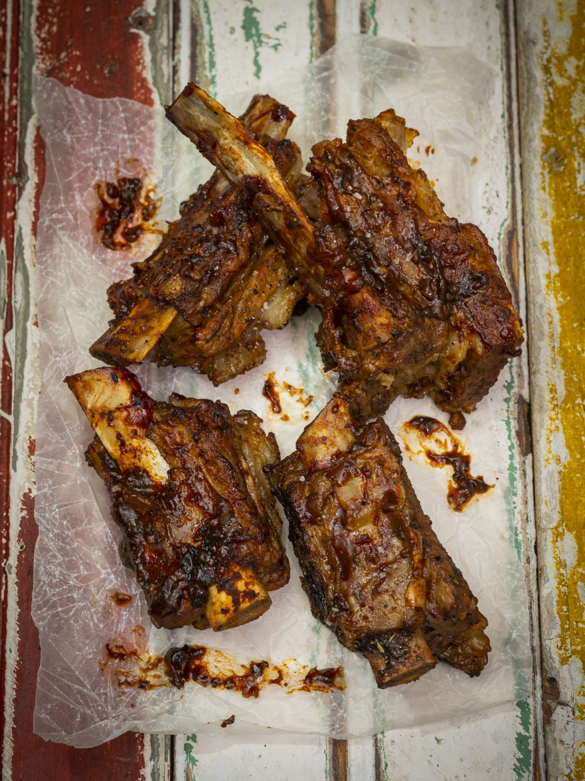
Short ribs in coke and brandy
Beef ribs are tough as nails and ideally need a lengthy cooking time on easy heat for best eating enjoyment. From scratch, it is unrealistic to braai on a grid and expect it to be tender. It would be like trying to braai oxtail on a grid and expecting it to be tender. The meat will be done,but will be unpleasantly tough to eat.
To my mind, you need to simmer the ribs gently in your potjie first to make them tender, then it’s the basting sauce and lastly, off to the grid for searing heat properties and flavour.

INGREDIENTS (SERVES 6)
- Cook and bake non stick cooking spray – Original
- 2 kg beef short ribs
- Water
- 1 tsp salt
- 2 tots brandy
- ½ cup cola
- ½ cup tomato sauce
- 2 tots Worcestershire sauce
- 1 tot paprika
- 2 garlic cloves (crushed and chopped)
- 1 tsp dried oregano
- 1 tsp black pepper

METHOD
- Supermarkets sell what they call ‘beef short ribs’. The way they cut it, you’re not buying actual riblets, but strips of meat cut across the grain and rib bones from that area of the carcass. If you want actual beef short ribs that look like riblets, phone a speciality butcher and order some. Either type will work for this recipe.
- Once home with your short rib strips or short rib riblets, add all of the meat to your potjie, add water till the ribs are just covered and then add the salt to that. Put the lid on the potjie and gently simmer the meat. If you’re using short rib strips, simmer for 60 minutes and if you’re using actual riblets, simmer for about 90 minutes until tender.
- Either way, once tender, drain the water from the potjie and leave the meat aside.
- Prepare your potjie with Cook and bake non stick cooking spray and place the meat back in.
- Now add the brandy, cola, tomato sauce, Worcestershire sauce, paprika, garlic, oregano and pepper to the meat in the potjie. Toss everything well, making sure all the meat is coated with sauce.
- You can now increase the heat under the potjie and continue to cook the ribs with the lid off until you’re happy with the stickiness of the sauce.
- Pack the short ribs on your braai grid over medium-hot coals and braai for a few minutes on each side until the meat sizzles and the sauce starts to caramelise. Be careful – all the sugars in the sauce will very easily burn so don’t braai for too long! As soon as it looks ready, it is ready. Remove from the grid and enjoy.

