Peppermint Crisp tart
6 servings Prep: 25 mins Chill/rest/proof: 1 hr
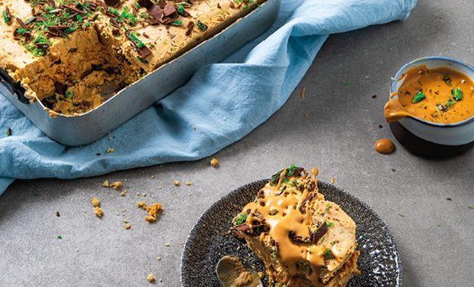

Ingredients(4)
200 g | tennis biscuits
360 g | Caramel Treat
2 cup | fresh cream
400 g | Peppermint Crisp chocolate — grated

Method:
Place the tennis biscuits in rows at the bottom of your desired dish, ensuring that the bottom of the dish is covered. Place the caramel in a mixing bowl and mix until smooth. In a separate mixing bowl, whisk the cream until stiff peaks form, being careful not to over-whip. Add the whipped cream and 100g of the grated peppermint crisp chocolate to the caramel and combine well.
Spread a generous amount of the mixture over the tennis biscuits and spread evenly. Add another layer of tennis biscuits and caramel mixture and continue this process untill your dish is full. Sprinkle the remaining peppermint crisp over the top and place in the fridge for 1 hour to set. Serve with a dollop of cream or as desired.

