**MASHATU DIRECTIONS FROM PLATJAN**

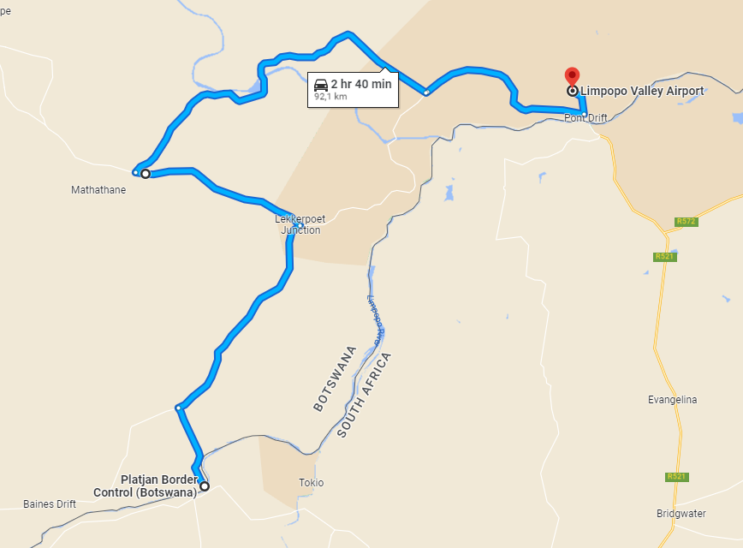

**From the Platjan Border continue driving for about 7km till you hit a T-Junction.**

**Take a right and continue driving for 20km till you reach a junction with a paved road. Take a left and drive on the tarred road for about 16km and you will see a Mashatu sign Board saying 50km.**

**Turn right and join a dirt road and drive for 50km to Limpopo Valley Airfield.**