Marshmallow s’mores

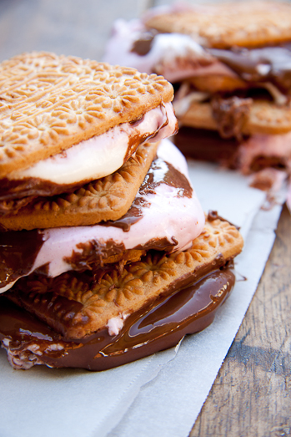

INGREDIENTS
- 300 g marshmallows
- 1 x 200 g Tennis biscuits packet
- 2 x 100 g white or caramel chocolate slabs, melted

COOKING INSTRUCTIONS
Thread 3–4 marshmallows onto metal skewers and carefully hold over a braai of cooling smouldering coals, turning often until the marshmallows are toasted and slightly charred with a soft centre.
Remove from the heat and sandwich the marshmallows between two Tennis biscuits and top with a drizzle of melted chocolate or Nutella!

