How to braai lamb chops
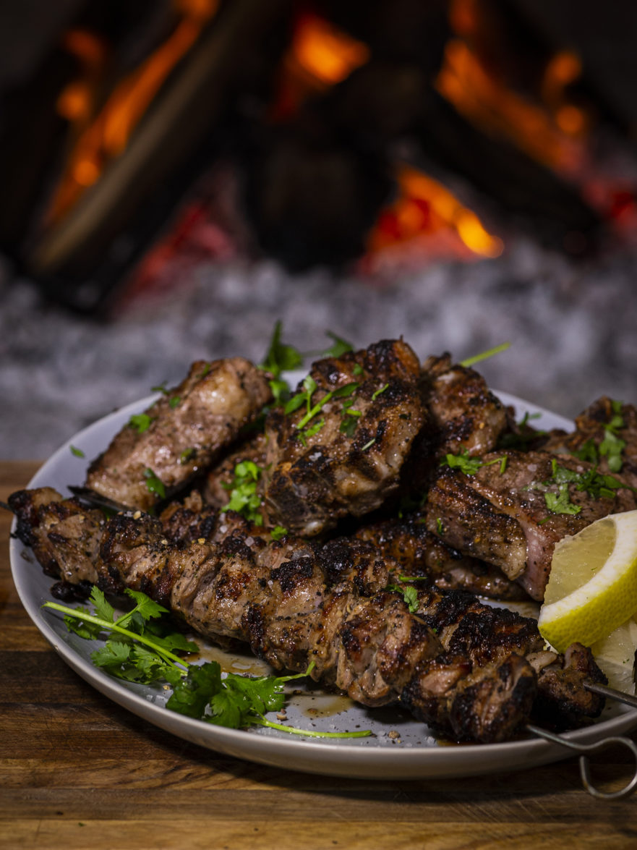

The lamb loin chop is that animal’s royal and most expensive cut of braai meat. It is exactly like a T-bone steak, but just from a lamb rather than a cow. There is a piece of sirloin and a piece of fillet. While the end of the loin chop often goes to waste, in this case, use your sharpest knife, cut it in smaller blocks and skewer. We need to keep the flavours simple so as to complement and not overpower the natural flavours of the meat. In addition to the trinity of garlic, olive oil and lemon juice, we know that the odd bit of coriander goes well with lamb. In this case, we’re giving it a double dose of coriander.

INGREDIENTS (SERVES 4)
- 12 lamb loin chops
- 2 cloves garlic
- 1 tot fresh coriander (also known as dhania; finely chopped)
- 1 tot fine coriander
- 1 tot lemon juice
- coarse sea salt
- Cape Herb and spice Lemon Pepper
- skewers

METHOD
- Use your sharpest knife and cut off the tail end of the lamb chop. Leaving the fillet and sirloin in place. Cut this longer piece of meat into bite size pieces and place onto a skewer
- Season the chops and skewers with salt, pepper and coriander. Chop or crush the garlic, chop the coriander leaves and add to the chops and skewers.
- Drizzle with lemon juice and let the meat marinate for as long as it takes your fire to burn out and form coals.
- Braai the chops and skewers over hot coals for 8 to 12 minutes until they reach that point between medium rare and medium where lamb tastes best. Lamb loin chops vary widely in size, and the heat of your fire will also play a role in how long they take to braai. Remember the golden rule: if you think it’s ready, it probably is. Some exceptionally small lamb chops are ready after 6 minutes, so use your common sense.
- Serve with additional fresh corianders and lemon juice.

