Home-made Granola
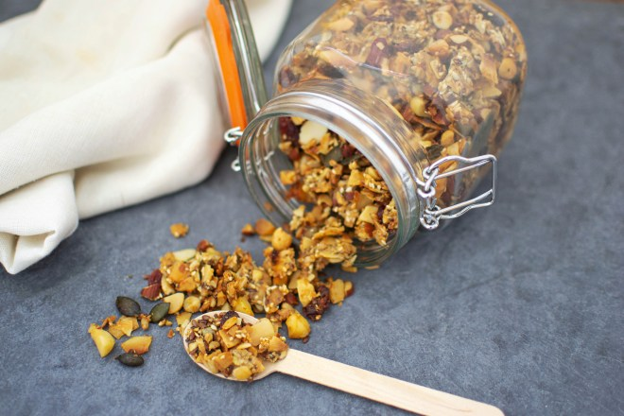

A versatile granola recipe that can be eaten for breakfast, as a snack or baked on top fruit for a quick and easy dessert. Serve with yogurt, milk, ice-cream or by itself.
Ingredients
- 5 cups (400 grams) oatmeal
- 1 cup (125 grams) wheatgerm
- 1 cup (125 grams) sunflower seeds
- 1 cup (150 grams) flaked almonds
- 1 cup (150 grams) pumpkin seeds
- ¼ cup (50 grams) brown sugar
- ½ cup (118 dl) honey
- 1 cup (236 dl) olive oil
- ½ teaspoon vanilla extract
- ½ teaspoon Maldon salt flakes
Instructions
- Mix the dry ingredients in a large bowl.
- Heat the honey and sugar in a small saucepan, then add the oil and vanilla.
- Add the liquid mixture to the dry and combine well.
- Spread on a cookie sheet and sprinkle with Maldon sea salt.
- Bake for 30 minutes at 350 F (180 C) stirring the granola half way through the baking time to ensure it browns evenly.
- Store in an air tight container in a cool place.

