Garlic bread three ways
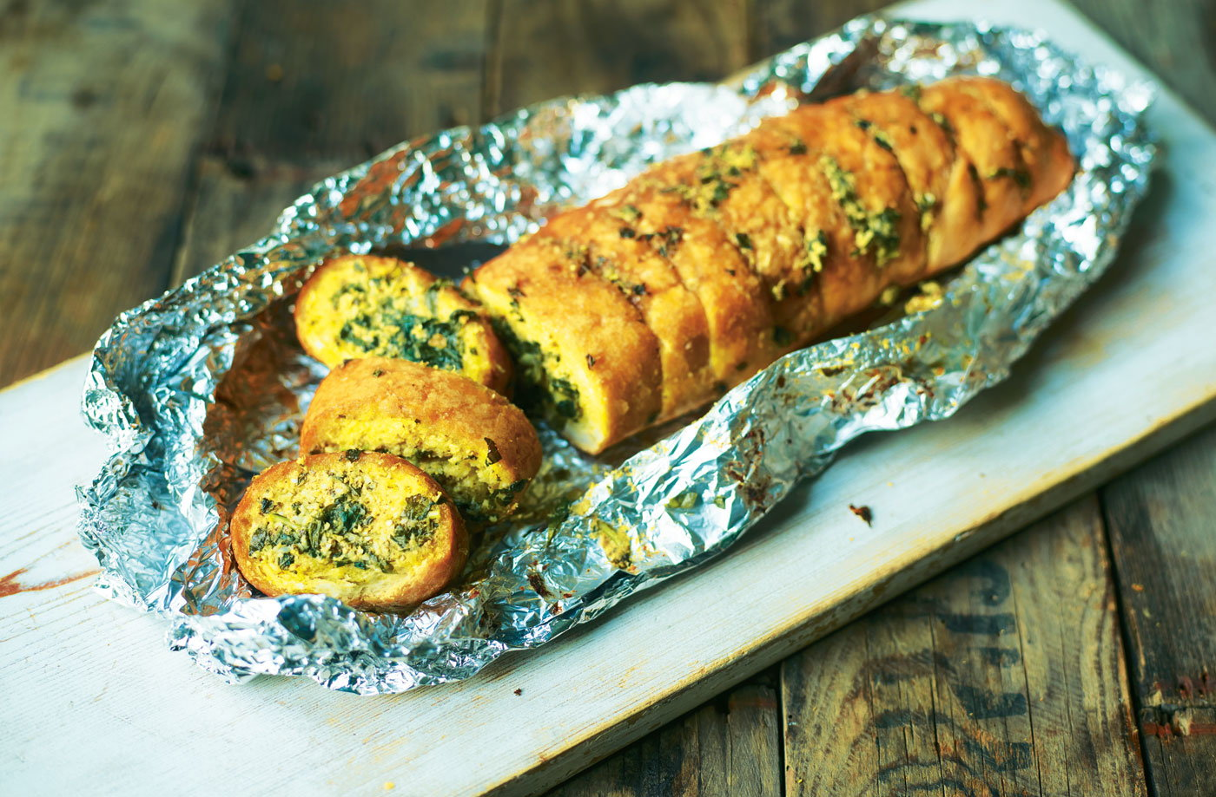

INGREDIENTS
3 baguettes
For the corn-and-Parmesan butter:
- 100 g butter
- ¼ cup olive oil
- 4 cloves garlic, crushed
- 1 cup corn, cooked
- ½ cup Parmesan
- black pepper to taste
For the classic garlicky green butter
- 100 g butter
- ¼ cup olive oil
- 4 cloves garlic, crushed
- ¼ cup fresh parsley, chopped
- ¼ cup basil
- ¼ cup chives

For the paprika butter:
- 100 g butter
- ¼ cup olive oil
- 3 cloves garlic, crushed
- 1 t paprika
- ½ cup Woolworths roasted red pepper pesto

COOKING INSTRUCTIONS
Corn-and-Parmesan butter:
Slice the baguette lengthways down the middle, but not all the way through.
Place 100 g butter, ¼ cup olive oil, 4 crushed garlic cloves, 1 cup cooked corn, ½ cup Parmesan and black pepper to taste in a food processor. Blend until smooth, season to taste and melt. Brush between the slices of baguette.
Classic garlicky green butter:
Slice the baguette lengthways down the middle, but not all the way through.
Place 100 g butter, ¼ cup olive oil, 4 crushed garlic cloves, ¼ cup chopped fresh parsley, ¼ cup basil and ¼ cup chives, sea salt and black pepper to taste in a food processor. Blend until smooth, then melt.Brush between the slices of baguette.
Paprika butter:
Slice the baguette evenly, but not all the way through.
Place 100 g butter, ¼ cup olive oil, 3 crushed garlic cloves, 1 t paprika and ½ cup Woolworths roasted red pepper pesto in a food processor. Blend until smooth, season to taste and melt. Brush between the slices of baguette.

