Easy Roosterbrood Recipe
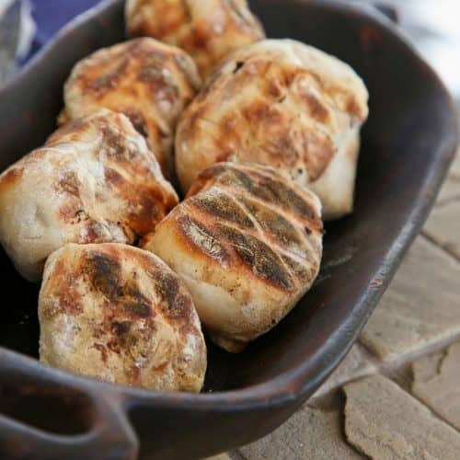

Serves: 36 rolls
Cooking Time: 1 hour

INGREDIENTS
- 1kg cake flour
- 15ml (1 tbsp) salt
- 30ml (2 tbsp) sugar
- 60g margarine
- 10g instant yeast
- 250ml (1 cup) milk
- 375ml (1½ cups) lukewarm water

INSTRUCTIONS
1
Mix all the dry ingredients together and rub the margarine in with your fingertips. Mix in the yeast. Add the milk and enough of the warm water to form a soft dough.
2
On a lightly floured surface, knead the dough until it is smooth and elastic. Cover and leave to rest for 5 minutes.
3
Knock the dough down, divide it into 36 equal pieces and shape into round balls. Place the balls on a greased baking tray, leaving enough space between them to allow for rising. Cover and leave to rise in a warm place until they have doubled in size, about 30 minutes.
4
Cook on a medium braai flame until golden brown, about 15 minutes.

