Crunchies
6 servings Prep: 15 mins, Cooking: 20 mins
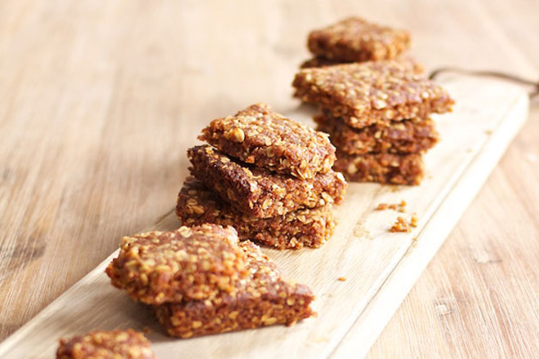

Ingredients(8)
1 1/2 cup | oats
1 cup | coconut
1 cup | flour
1/2 cup | sugar
1 tsp | Bicarbonate of soda
125 ml | margarine — melted
2 Tbs | golden syrup
4 Tbs | water

Method:
Combine oats, coconut, flour, sugar and bicarbonate of soda.
Mix and make a well in the centre.
Add margarine, golden syrup, boiled water to well.
Mix and knead together. Do not squash.
Put mixture in a baking tray and flatten. Use the back of a tablespoon to smoothen.
Bake at 150°C for +/- 20 min or until golden brown.
Cut while it’s hot (it should be soft) and allow to cool and harden.

