Crispy almond French toasts
with summer fruits
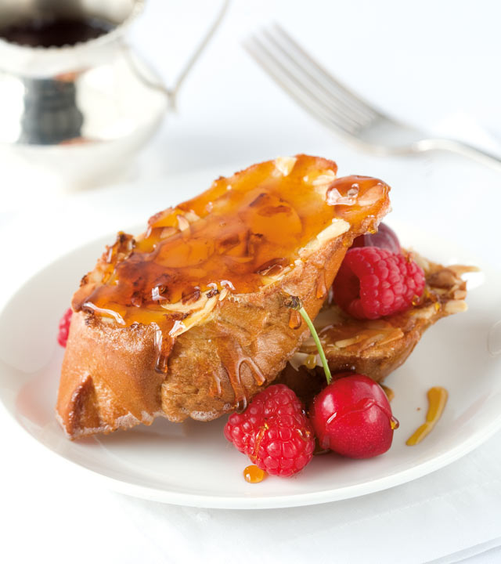
(serves 2)
1 egg
1 cup milk
½t almond extract (optional)
½ leftover French loaf, sliced
½ cup flaked almonds
butter, for frying
leftover mixed fruit or berries, to serve
maple syrup, to serve
Whisk the egg, milk and extract together. Dip the bread in the egg mixture and then into the flaked almonds. Fry in a pan until golden brown. Serve topped with mixed berries and drizzled with maple syrup.

