CONDENSED MILK AND SWEET CORN BREAD
Cook: 45-60 min

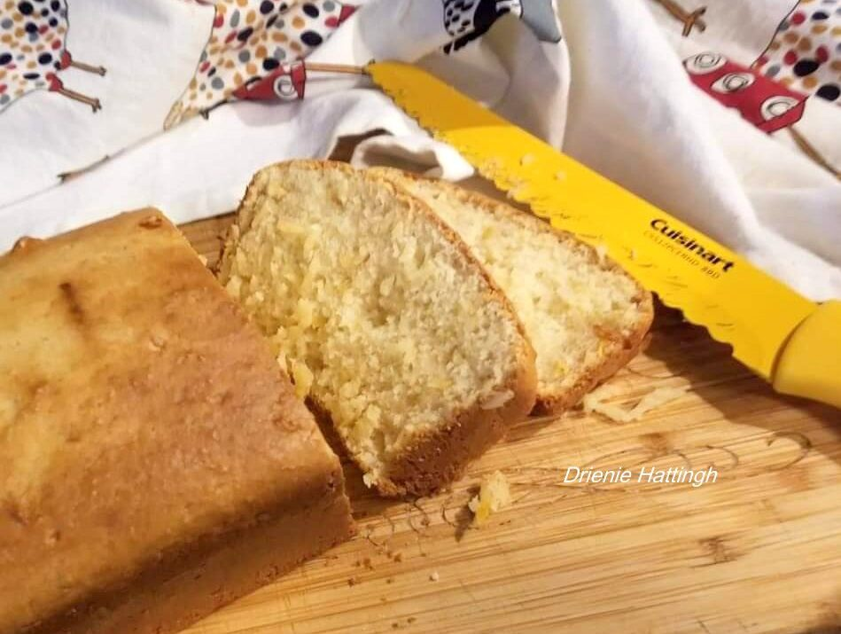
- 2 cups self raising flour
- pinch of salt
- 1 tin condensed milk
- 1 tin creamed corn
Mix together and bake at 350ºF (180 ºC) for about an hour.
Test to see if it is baked through.

