Biltong Recipe

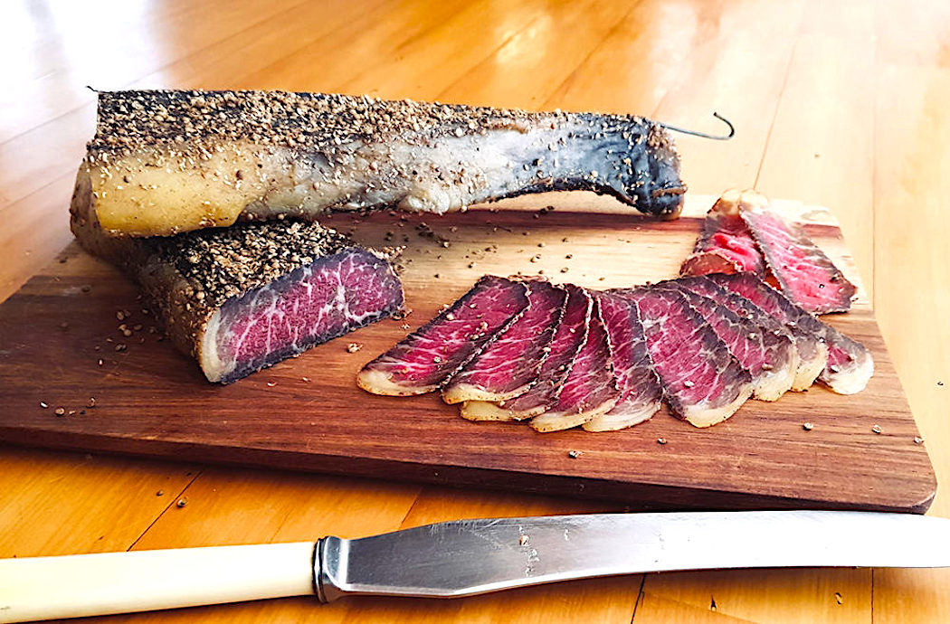

INGREDIENTS
- 3 kg beef (silverside)
- 1 cup grinded coarse salt and black pepper, mixed
- 1 cup coriander seeds
- 9 whole cloves
- 10 whole allspice seeds
- balsamic vinegar

METHOD
- Dry your meat with a paper towel to remove the moisture.
- Slice the meat into suitable strips.
- On medium setting, heat a frying pan and add the coriander seeds. Stir until you can smell the coriander aroma – do not toast the seeds. Remove from heat.
- Add the coriander seeds, allspice and cloves to a mortar and grind into small pieces. Make sure it’s not too fine.
- Rub the meat on both sides with the balsamic vinegar, then the ground salt and pepper and sprinkle the spices on both sides. Wrap each slice of meat in cling wrap and let it stand overnight in a cool place.
- The next day remove the cling wrap, shake off a little of the extra salt and spices.
- Hang each slice of meat on a hook in a dry and airy place.
- BILTONG
- Hang the meat to dry as you like it. For the first few days you can use a fan on the hanging meat to help the drying process.
- CARPACCIO

